A short guide to setting up Club and Athlete in Ophardt
Step 1
Register as club admin with Ophardt
https://fencing.ophardt.online/en/home

This takes you to
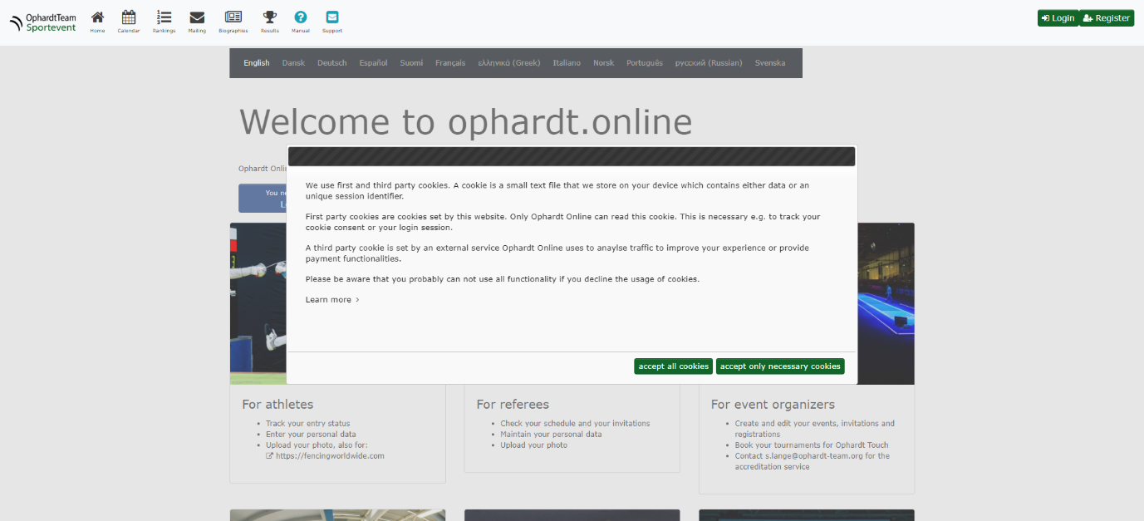
Accept cookies and then register by clicking on the red register button or the register icon in the top right corner
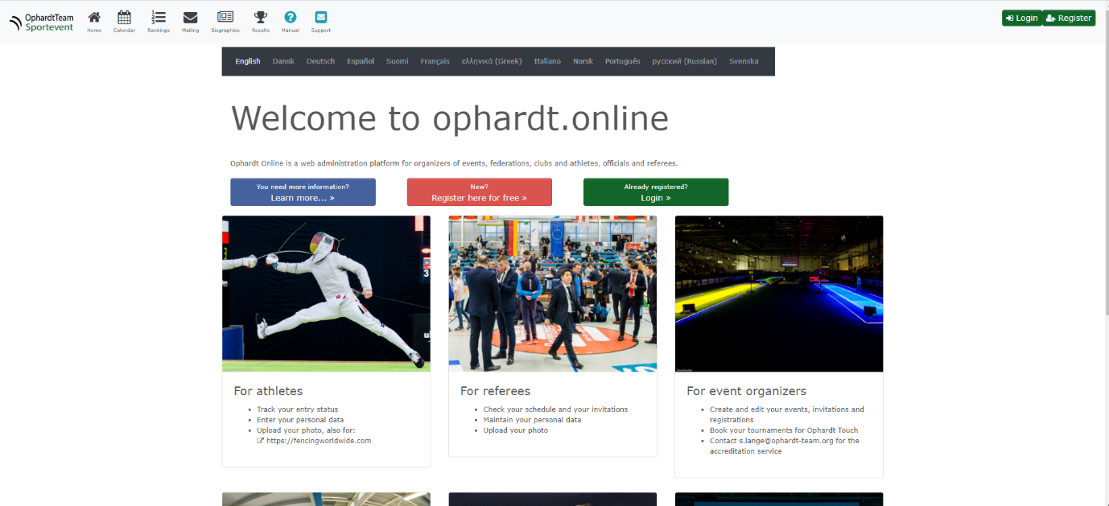

Clicking on registration takes you to a simple screen where you can input the basic data for your club
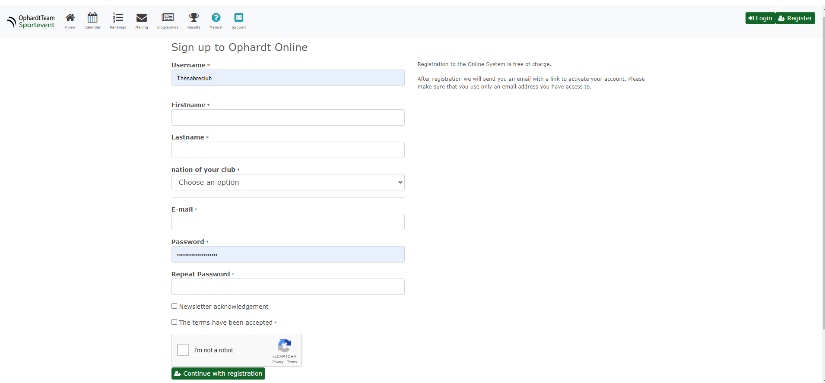

The screen says we will send you an email. However, in the set up stage, to save Ophardt a lot of admin, we ask you to please
Send an email with club name and the email you used to register to peter.howes@englandfencing.org.uk
Peter Howes will check with you if you are authorised to be club admin by asking for some information and/or checking the club website and/or other sources of information.
You will then be granted admin rights for your club.
Step 2
Registering fencers
Log in
Choose your role as admin by selecting the button in the box on the right hand side. If you don’t select the club role you won’t be able to do stuff as the system will tell you admin authorisation is required.
Then from the top menu select CLUB and then PERSONS
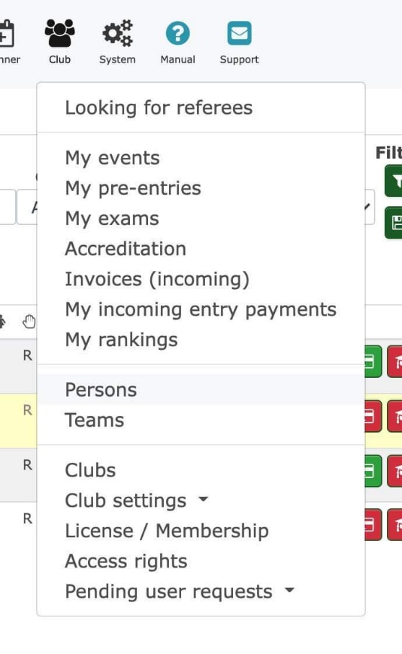

Then select the green button: New person or transfer/add club

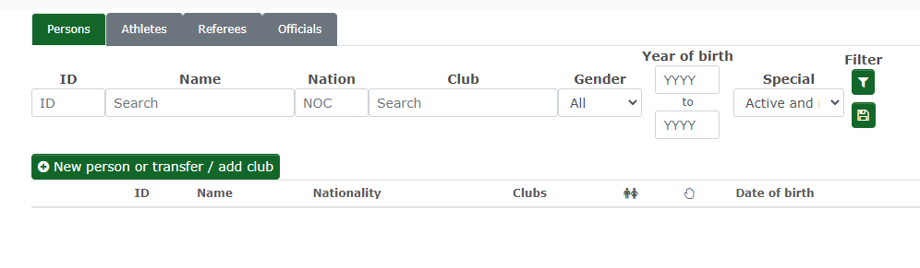
This will open up a form
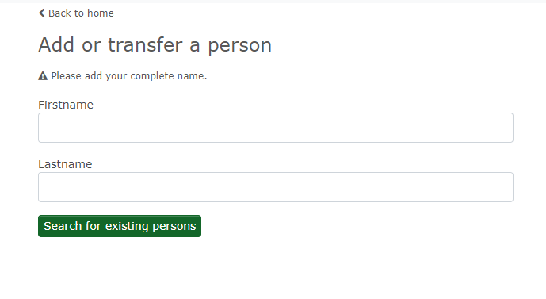
The first thing to do is to check if they are already in the system so you click the Search for existing persons button.
If you have done a competition this year and the results are in Ophardt, the likelihood is the person already exists but the details may be wrong and they won’t yet be associated with your club which is why the rankings won’t show the club.
You will be shown a screen with any existing fencers of that name at the top
If they already exist, their record will show up at the top of the page. The details you entered to search will show up at the bottom as sometimes fencers have the same name but are different people.
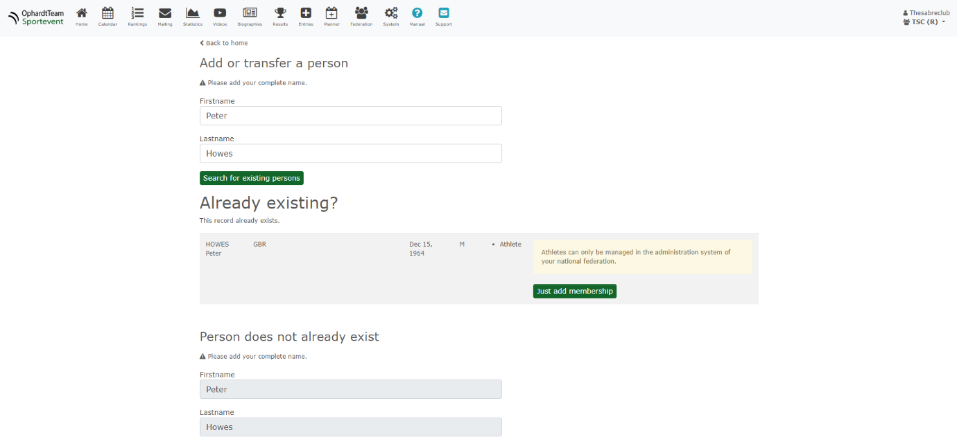

You can then click Just Add Membership to associate them with your club. This will bring up a screen where you can add some details such as the date they joined the club and their email.
You should add their email so you can then send them an invitation to sign up to Ophardt themselves.
Step 3
Editing Fencer details
Select the fencer from the Persons list under Federation.
You can search for them.
Set the clubs field to All as otherwise they won’t show up if not affiliated to a club.
The name search works by Surname first. You usually don’t need to put in the whole name.
Click the green filter button on the right of the search bar to bring up the results.
Then just select the fencer and use the grey edit button on the right of their name.
Some details will be in light grey.
That just means you need to go to the bottom of the form and put what you need in the Change Request box.
For instance DOB and Nationality can only be changed here.

Step 4
Editing Club details
Under Federation in the top menu
Click on Clubs
Then edit similarly to how you do it for Fencer details in 3 above.

….

