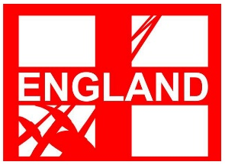

England Fencing Selection Document and Ranking Calculation for Youth International Development events 2021

Epee | Foil | Sabre
International Youth Fencing Cup  Ghent, Belgium | CEP Marathon  Paris, France | Trofeu Sant Jordi  Barcelona, Spain

- SELECTION SUMMARY

From 2021 we will be focusing on events to develop fencers using international events for U14 with birth years 2007/08

The England Fencing rankings will reflect fencers’ results who fenced in the right age category in the domestic selection events listed in section 3 and achieved ranking points as set out in section 4 of this document.

Selection for international events will be made directly off the published rankings with no discretion and subject to good disciplinary record.

8 fencers for each weapon and gender will be selected for U14 international events from the relevant England Age Group Rankings.

Commonwealth Championships for U17 (Cadet) U20 (Junior) and Youth 5 Nations will be detailed in a separate document and will not form part of a development programme in 2020/2021

- SELECTION DATES
The selection will be made after the last selection event for that weapon up until the on the 2nd December 2020.
Places will be allocated in order of rank. If the date of any foreign events has changed significantly and the selection date has to be changed then this fact will be publicised on the England Fencing website and via England Fencing social media.
Fencers considered for selection will be limited to the top 20 of the England Fencing weapon ranking lists (http://englandfencing.co.uk/rankings/) If you wish to be considered for selection for England, please ensure your personal information is up to date with British Fencing Sport 80 membership platform.
3) SELECTION EVENTS

The ranking lists shall include the fencer’s best 5 results from the following competitions in a calendar year from 2nd December 2019 until the 1st December 2020. If an event has moved so it falls in the same ranking year, the latest competition results will count towards 2021 selection.

a) British Youth Championships 2020 (U12 and U14)
b) England Youth Championships 2020 (U13)
d) Leon Paul Junior Series competitions (U13)
f) The Youth Series events (U12, U14)
g) Additional competitions:
i) for Foil: Newham Swords Junior Challenge Series events U12 + U14
ii) for epée: Elite Epee U12, U14 open competitions; Cocks Moor Epee U13
iii) for Sabre: Stratford Sabre U12 + U14.
iiii) Open youth competitions with for ages U12 and U14 who have applied for inclusion to the ranking scheme (Conditions apply. Submissions to Head of Representative fencing beth.davidson@englandfencing.org.uk)

- RANKING SYSTEM

4.1 The ranking list co-ordinators will assign points according the to the final position achieved in the competition. (See point 5)
4.2 Points are only awarded to fencers finishing in the top 50% of the competition and only if they finish in the L32. This will be rounded down of the 50% calculation.
4.3 The BEST 5 results count for your England Ranking.
4.4 There will be no rolling rank or carry over. Points will be calculated from competitions taking place in the calendar year from December 2nd 2019 until the 1st December 2020

- HOW POINTS WILL BE CALCULATED
The points for a competition are calculated by multiplying

(Number of fencers in competition) x (Age group multiplier) x (Position multiplier)

The Number of fencers in the competition speaks for itself but for the elimination of doubt this will include any starter who has to abandon or is removed from the competition for disciplinary reasons.

The Age group multipliers will be 1 for U12+U13 competitions; 2 for U14 competitions

N.B. A further multiplier of 1.2 will be applied to those competing at the 2020 EYCs

Position Multipliers
The conventional position multipliers that we use at Senior comps are designed to spread over 64 places and are not ideal for a system that only gives points for a L32, or for comps with only 15 or 20 entries. We have used a different multiplier as follows:

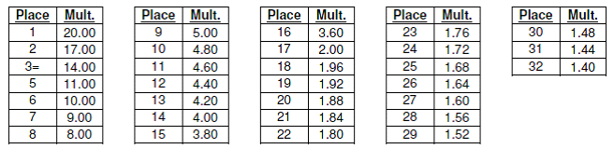
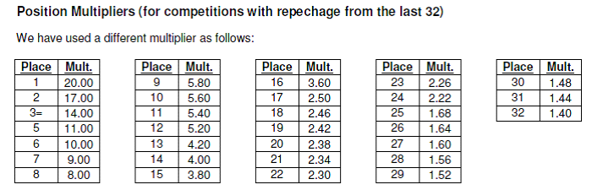

Note that there are steps in the position multiplier table at 3rd/5th, 8th/9th and 16th/17th rewarding the fencer who succeeds in winning more DE fights. The effect of this is that a fencer might earn more points for a 12th place in a large competition like the BYC U14 than they would by coming 3rd in a relatively small LPJS.

6) ELIGIBILITY FOR SELECTION

- You must be a British Citizen and hold a UK passport on the selection date.
- You must also be eligible to represent GBR at international level
- You must be a member of England Fencing

Qualifying fencers must be members of England Fencing at the time of selection and at the time of the event, must agree (with parental consent) to the code of conduct and conditions (including financial and travel arrangements) of the trip. England Fencing Ltd reserves the right to withhold selection from fencers with an unsatisfactory disciplinary record, or with an outstanding debt to EF or its agents.

In the event that England Fencing is unable to contact a selected fencer within a reasonable time-scale, the offer of selection may be withdrawn and offered to the next available fencer from the rankings.

Fencers must ensure their personal British Fencing Membership details are up to date as these will be used for all correspondence.

7) APPEALS
Any appeal against the accuracy of the final rankings must be made to the ranking keeper within 7 days of the publication of the final rankings. If this does not resolve the issue a further appeal may be made within 10 days of the publication of the final rankings to the Director of Representative Fencing whose decision shall be final.

8) AGE CRITERIA
We wish to encourage fencers not to ‘fence up’ into a higher age groups even though some competition organisers allow this discretion.

Ranking points achieved in the selection events will be allocated to a fencer who fences in their correct age group for International events in 2021. This is to account for change of age groups on 1st January 2021.

Link to England Fencing ranking lists: http://englandfencing.co.uk/rankings/

Questions specific to the ranking lists should be directed to the ranking co-ordinators:

Foil – Debbie Porter englandfoilrankings@gmail.com

Epee – Rodney Francis (rodneyfrancis@hhl.me.uk)rankings: http://francisfencing.org.uk/wroclaw/

Sabre – Maxine Foxwell-Moss maxine.fm67@gmail.com

For questions about the overall purpose and management of international trips, please contact Beth Davidson Director of Representative Fencing E-mail: beth.davidson@englandfencing.org.uk. 07834884194

