THIS IS AN UPDATED SELECTION DOCUMENT TO APPRECIATE THE BOARD DECISION TO SELECT AN U13 AND U15 ENGLAND SQUAD FOR INTERNATIONAL EVENTS

Fencers will be selected for U15 and U13 Events 2016 as follows:

- SELECTION SUMMARY
Fencers finishing in the top 4 of the 2015 EYC U15 or EYC U13 will be selected automatically provided that they meet the age criteria. For the 2016 foreign events, that requires year of birth 2001 or later. In practice, this means that only U15 fencers in their first U15 year in 2015 will qualify, because the target event is U15 in 2016. All 2015 U13s will still be U15 in 2016

- SELECTION DATES
The selection date will normally be 10 days after the final competition of 2015 and selection will not be subject to any discretion. Places will be allocated to the highest ranked fencers (excluding those already qualified via the EYC). If the date of any foreign event is brought forward significantly and the selection date has to be changed then this fact will be publicised on the England Fencing website.
2a For the foil competition in Paris the remaining places (to a total of 12 in each gender) will be allocated according to ranking lists maintained for the purpose.

Note: It is the intention to include an U13 foil squad for season 2016/17

2b For the sabre and épée events in Wroclaw the remaining places (to a total of 12 in each gender born in 2001 or 2002) will be allocated according to U15 ranking lists maintained for the purpose. In addition further places will be allocated (to a total of 6 in each gender born after 2002) according to U13 ranking lists maintained for the purpose.
3) SELECTION EVENTS
The ranking lists shall include results from the following competitions: Only the BEST 5 results count.
a) British Youth Championships 2015 (U12 and U14)
b) England Youth Championships 2015(U13 and U15)
c) British Cadet Championships 2015 (U17)
d) Leon Paul Junior Series competitions in the relevant weapon (U13 and U15) in the
calendar year 2015 up to the selection date*
e) Any additional competitions that the England Fencing Director of Representative
Fencing may nominate. For 2015:
i) for Foil: the Manchester Cadet Tournament, BRC U17 competitions and the
Premier Foil Series;
ii) for Epée: BRC U17 competitions, the Young Hoskyns (U13) and the Elite Epee
Series; Cocks Moor Epee
iii) for Sabre: BRC U17 competitions and the Stratford U14.

- RANKING SYSTEM
The ranking list co-ordinators will assign points according to a system approved by the England Fencing Director of Representative Fencing to weight the results for both the number of entrants and the relative standard of entrants in any given competition.

- ELIGABILITY
Qualifying fencers must be members of England Fencing Ltd at the time of selection and at the time of the event, must agree (with parental consent) to the code of conduct and conditions (including financial and travel arrangements) of the trip. England Fencing Ltd reserves the right to withhold selection from fencers with an unsatisfactory disciplinary record, or with an outstanding debt to EF or its agents.

In the event that a team manager is unable to contact a selected fencer within a reasonable time-scale, the offer of selection may be withdrawn and offered to the next available fencer from the rankings.

- APPEALS
Any appeal against the accuracy of the final rankings must be made to the ranking keeper within 7 days of the publication of the final rankings. If this does not resolve the issue a further appeal may be made within 10 days of the publication of the final rankings to the Director of Representative Fencing whose decision shall be final.

- AGE CRITERIA
For the events, which have multiple age groups, selected fencers will be entered in the lowest age group compatible with their date of birth, meaning fencers do not ‘fence up’ into a higher age group.

Although every effort will be made to provide accurate and timely information, England Fencing Ltd. reserves the right to alter the selection policy without notice.

Notes:
i) The main purpose of these trips is to introduce young fencers to the international competition environment and to the atmosphere and requirements of working within a squad. This inevitably leads to some restrictions, which may not apply were the fencer to enter individually, but, more particularly, gives significant benefits.
ii) Accepting a place on an England Squad may restrict the right of a fencer to represent another country in the future. Individuals who are eligible to represent more than one country should consider these factors before accepting selection.
iii) Both Paris and Wroclaw accept private entries in addition to representative squads from national federations. England Fencing encourages fencers who were close to selection to make private entries and the team managers will do their best to help with practical arrangements. However the standard of these events is extremely high and they are not appropriate for inexperienced competitors.

- How points are calculated
The points for a competition are calculated by multiplying the NIF x Position multiplier. NIF is a value reflecting the strength of a competition. The position multiplier is a range of values between 1.4 and 20. The higher the fencer is placed, the higher the multiplier.

Note that there are steps in the position multiplier table at 4th/5th, 8th/9th and 16th/17th rewarding the fencer who succeeds in winning more DE fights. The effect of this is that a fencer might earn more points for a 12th place in a strong competition like the BYC U14 than they would for coming 3rd in a relatively weak LPJS.
Weighting the competitions (NIF) obviously some competitions are harder than others. This is a function of both the quality and the quantity of the opposition. We have borrowed the concept of NIF from adult competitions. The idea is that you look at the list of entrants to a competition and allocate a value to each fencer relative to their overall seasonal performance. In order to do this one has to have some benchmark of performance which in this case is the EYC and BYC competitions plus in certain cases the British Cadet rankings.

We have designated certain fencers to have a youth NIF as follows:

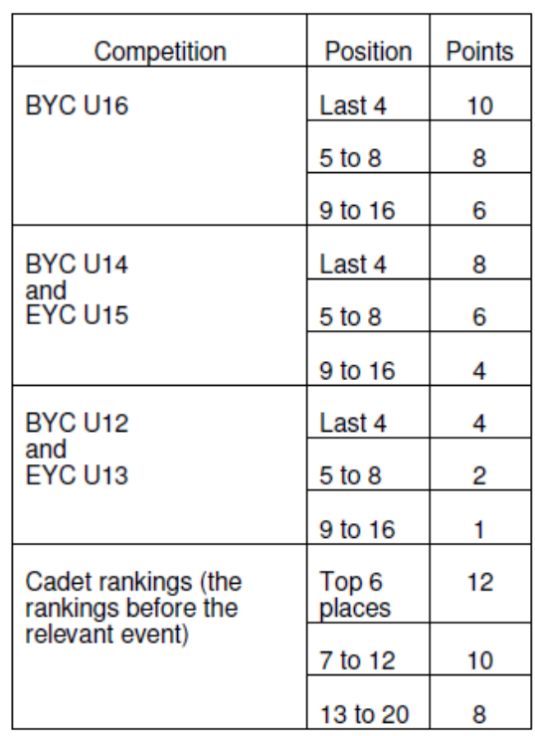

We also add ¼ of a NIF point for every non-NIF fencer attending a competition. Sometimes a fencer qualifies for different NIF values, in which case the higher value is used. For example, the Ashton LPJS Foil 2007 U13 had 18 entrants. Clyde (NIF 8), Davis and Cruise (NIF 4 each), Williams, Lee and Roberts (NIF 2 each) and Selby, Bailey and Collier (NIF 1 each) plus 9 non-NIF fencers at a ¼ point each. Total NIF for that comp was27.25.At Eton LPJS Foil 2007 U13 however, many more strong fencers competed, as well as 42non-NIF fencers, so that NIF was 53.5.

Position Multipliers
The conventional position multipliers that we use at Senior comps are designed to spread over 64
places, and are not ideal for a system that only gives points for a L32, or for comps with only 15 or 20
entries. We have used a different multiplier as follows:

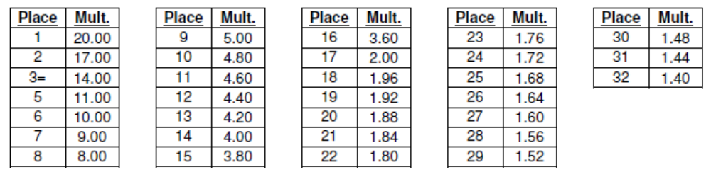
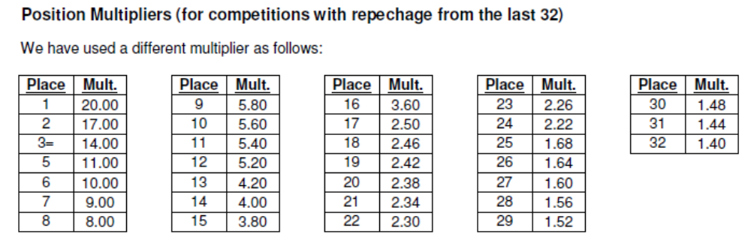
Points are only awarded to fencers finishing in the top 50% of the competition and only if they finish in the L32.

Only the BEST 5 results count.

Questions specific to the ranking lists should be directed to the ranking co-ordinators:

Foil – Sandra Beardmore (EnglandRankings@aol.com)rankings: http://www.englandfencing.org.uk/ _ Competitions and Teams _Rankings

Epee – Rodney Francis (rodneyfrancis@hhl.me.uk)rankings: http://francisfencing.org.uk/wroclaw/

Sabre – Daniel Redshaw (daniel.redshaw@live.co.uk)

For questions about the overall purpose and management of the trips or to volunteer to help, please contact Beth Davidson Director of Representative Fencing E-mail: beth.davidson@englandfencing.org.uk. 07834884194

